Early Childhood Networking Shareshop

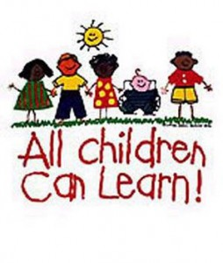
CESA #12 Conference Center
April 27, 2012
Registration: 8:30 AM – 9:00 AM
Training: 9:00 AM – 3:30 PM

Overview
Supporting Deaf or Hard of Hearing Children in Your Program: What Do You Need to Know?
Attend this interactive session and increase your knowledge of how a hearing loss impacts a child’s development (language development, social emotional development, cognitive/play development). Information shared will include: hearing loss identification/simulations; the unique needs of children with hearing loss; strategies to support development; and cultural discussions/ideas for applying these strategies. Participants will engage in a variety of learning activities including a presentation, question/answer session and small group discussions.

Presenter:
Sherry Kimball – MA Deaf education Birth to 6 Coordinator of Wisconsin Educational Services Deaf and Hard of Hearing Outreach (WESP-DHH)

Wisconsin State Performance Plan Indicators & Standards Addressed

Wisconsin's State Performance Plan Indicators: 6,7,8,12
Wisconsin Teacher Standards Addressed: 1,2,3,4,5,6,7,8,10

Target Audience
Birth to 3 Professionals, 4 year-old Kindergarten Teachers, Child Care Providers, Head Start Teachers,
ECSE Teachers, Administrators, Directors of Special Education, Speech and Language, and anyone interested in the care and education of young children.

Registration Fee: No Fee
This professional development opportunity is supported through funding from the IDEA Preschool Discretionary Project #12-74-9912 – PIDEA60 (CFDA #84.173)

Substitute and mileage reimbursement is available for Early Childhood Program Support participating school districts only. (Ashland, Bayfield, Butternut, Chequamegon, Drummond, Hayward, Hurley, Maple, Mellen, Mercer & Washburn)

Deadline for Registration
April 20, 2012

* Viterbo University Credit Available *

Registration must be completed on: www.myquickreg.com

